COMP – 371 Software Development And Construction
Lab Manual 06

Spring Data JPA MYSQL

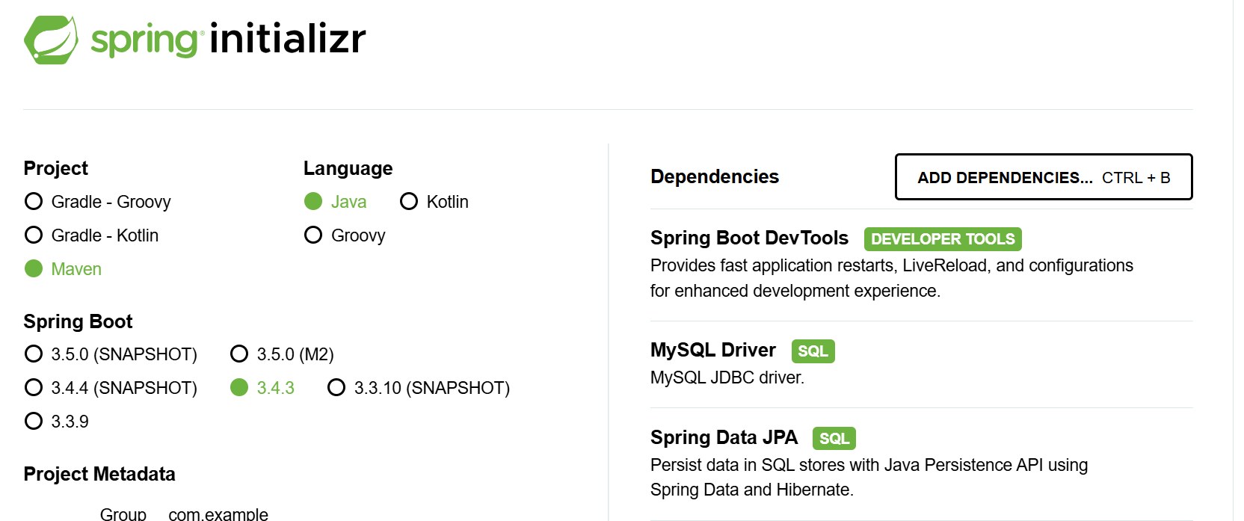

Spring Data JPA with MySQL is a technology stack that simplifies database operations in a Spring Boot application by combining the following concepts:
Spring Data JPA:
This is a Spring module that provides a high-level abstraction for data access. It allows you to define repository interfaces for your entities (your domain objects), and it automatically implements standard CRUD (Create, Read, Update, Delete) operations without the need to write boilerplate code.
Complex and Slow approach:
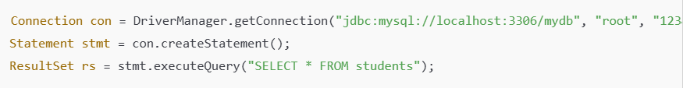
Find, Save, Delete are done automatically.
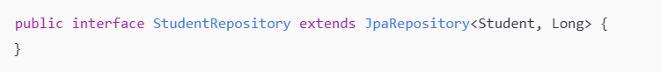
JPA (Java Persistence API):
JPA is a specification for object-relational mapping (ORM). It defines how Java objects map to database tables. When you use Spring Data JPA, you usually rely on an implementation (like Hibernate) to manage these mappings and execute SQL queries behind the scenes.
MySQL:
MySQL is a popular open-source relational database management system. In this stack, MySQL serves as the database where your application’s data is stored. Spring Boot integrates with MySQL by reading connection properties (like URL, username, and password) from configuration files (e.g., application.properties/applications.yaml).
Download MySQL Installer :
https://dev.mysql.com/downloads/installer/

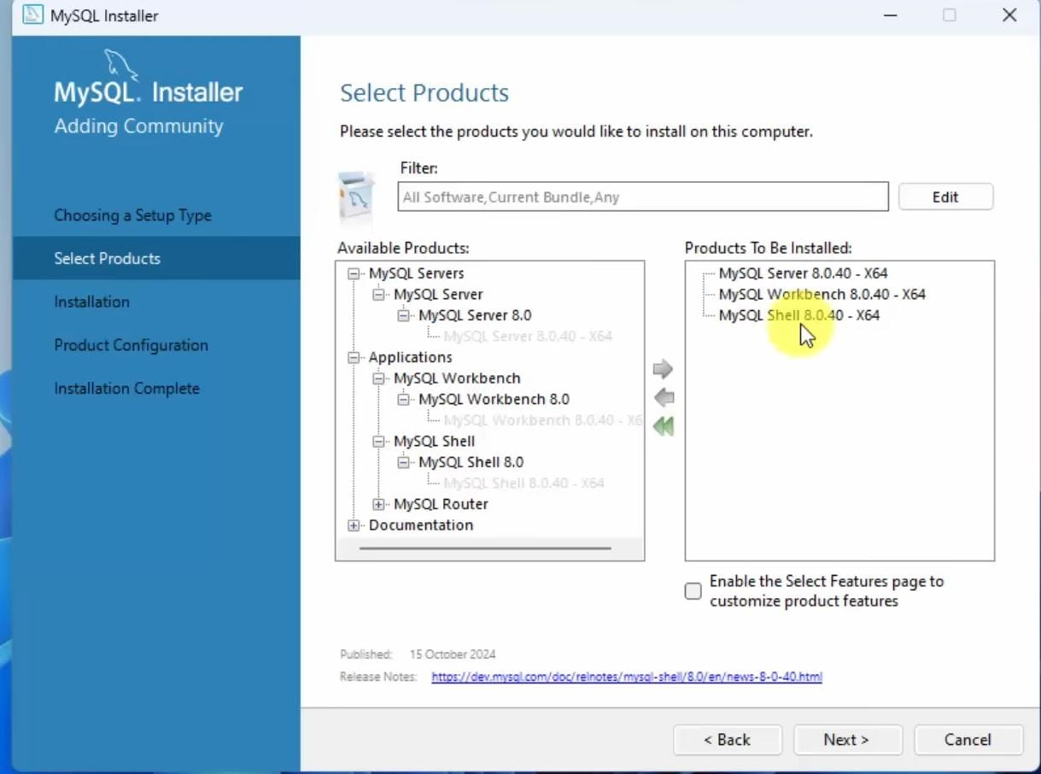

Wait Until it installed Successfully:

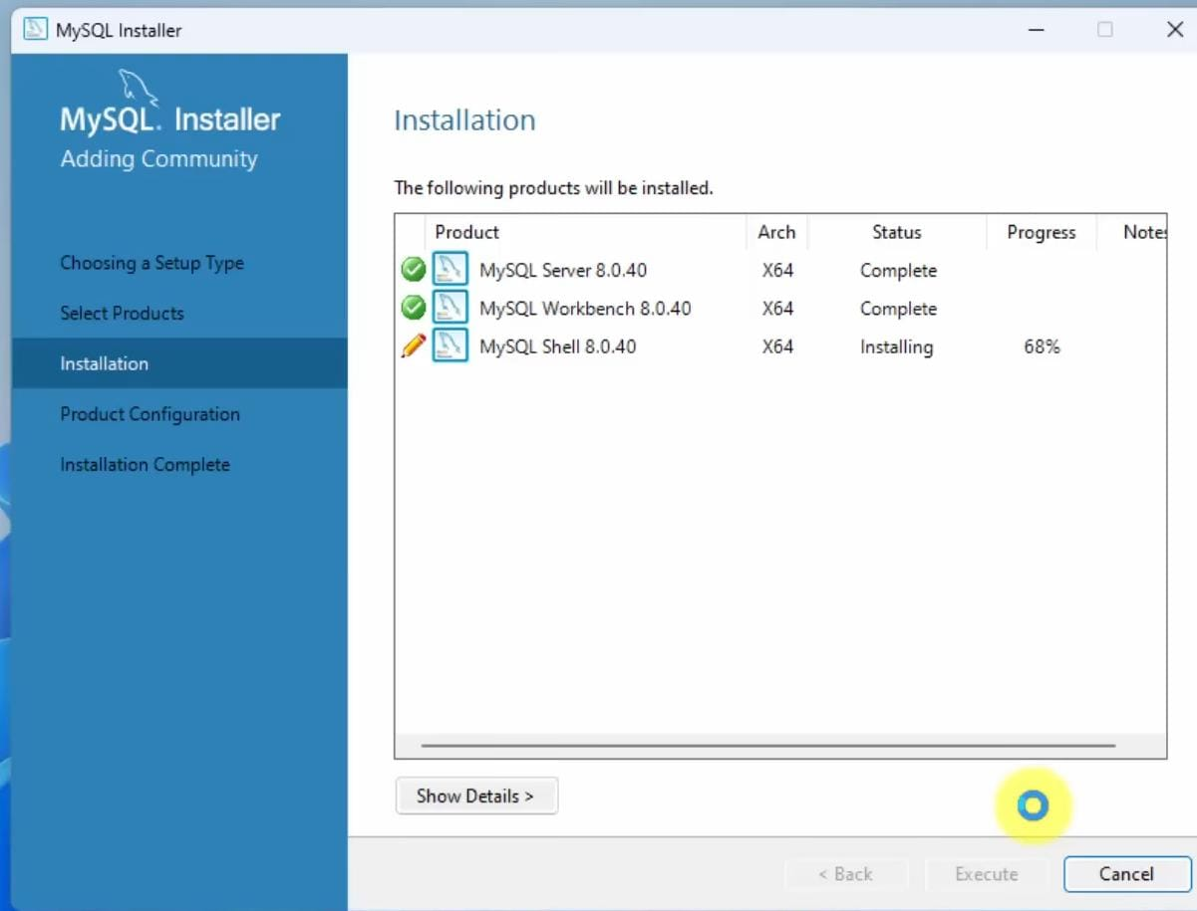

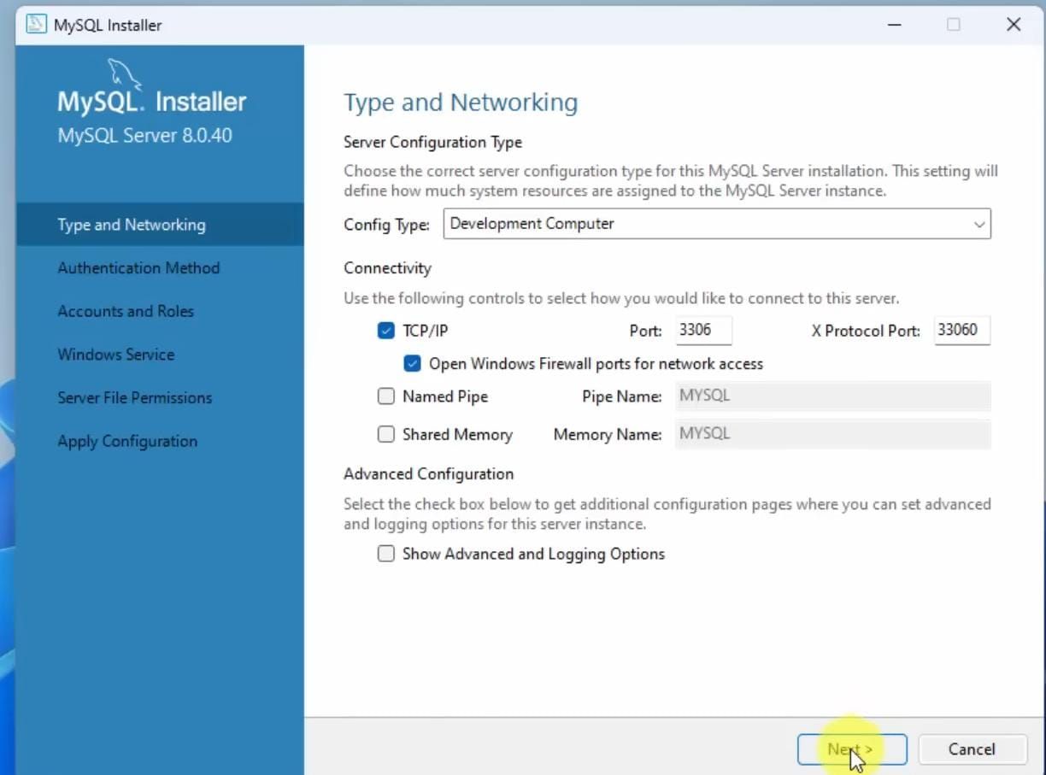
Set Your Root Password:
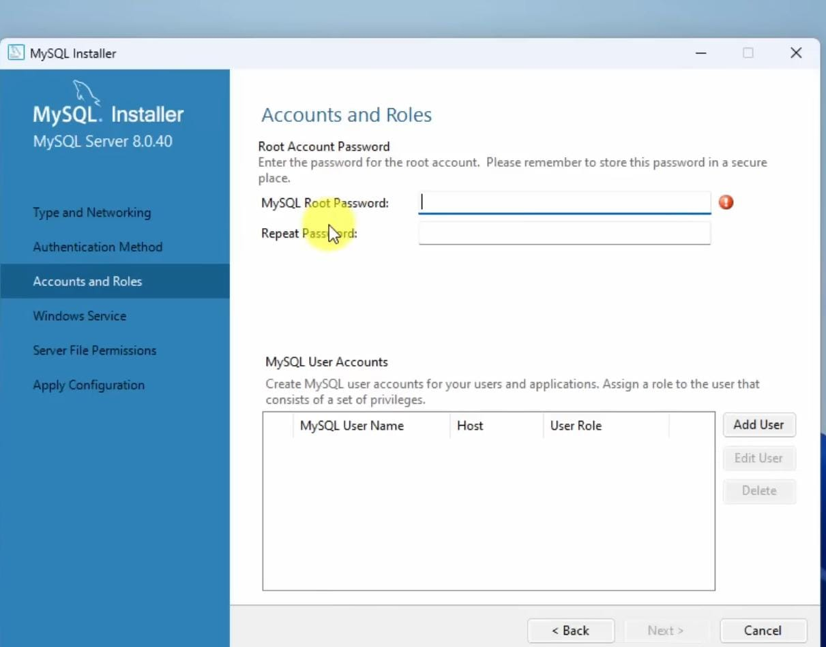
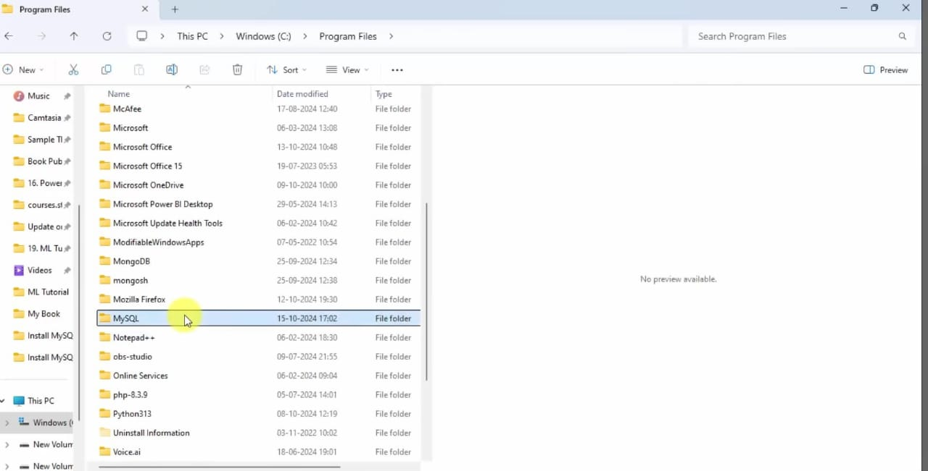
Select the path
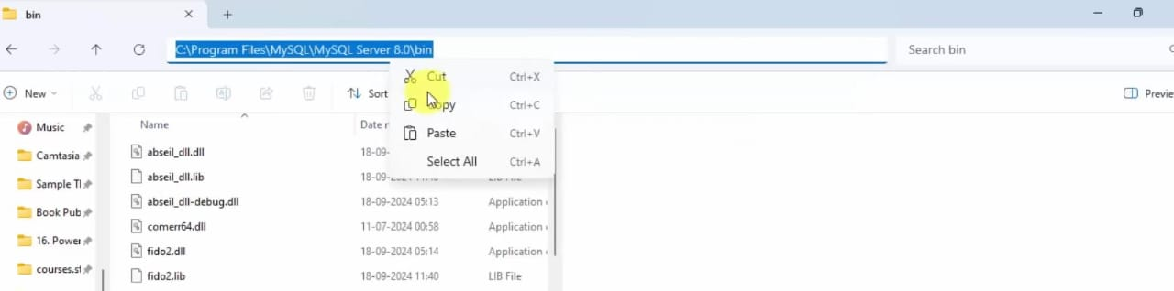

Save this path to the Environment variable .

How It Works Together
1. Entity Mapping:
Java classes (entities) are mapped to database tables using JPA annotations such as @Entity, @Table, and @Id. For example, a StoreInformation class can be associated with a store_information table in MySQL.
2. Repository Interfaces:
Extending interfaces like JpaRepository allows the creation of repository interfaces for entities. Spring Data JPA automatically implements these interfaces, providing methods like findAll(), findById(), save(), and delete(), significantly reducing boilerplate code.
3. Configuration:
In a Spring Boot application, the connection to MySQL is configured by specifying properties such as database URL, credentials, driver class, and JPA settings.

application.yml

spring:
application:
name: jpa
datasource:
url:
jdbc:mysql://localhost:6000/my_schema?allowPublicKeyRetrieval=true&useSSL=false&serverTimezone=UTC
username: root
password: 1234
driver-class-name: com.mysql.cj.jdbc.Driver
jpa:
database-platform: org.hibernate.dialect.MySQLDialect
hibernate:
ddl-auto: update
server: port: 8080

These properties tell Spring Boot how to connect to your MySQL database and how Hibernate (the JPA implementation) should manage your schema.
Automatic SQL Generation:
When your application runs, Spring Data JPA uses Hibernate to automatically generate and execute SQL statements based on your repository method calls. For example, calling storeRepo.save(store) triggers an INSERT or UPDATE statement in MySQL without you having to write the SQL manually.
REST API Integration:
With Spring Boot, you often expose your database operations as RESTful endpoints. Using controllers, you can map HTTP methods (GET, POST, PUT, DELETE) to repository methods. This allows tools like Postman to be used to test your API endpoints, which in turn perform operations on your MySQL database.

CREATE DATABASE my_schema;
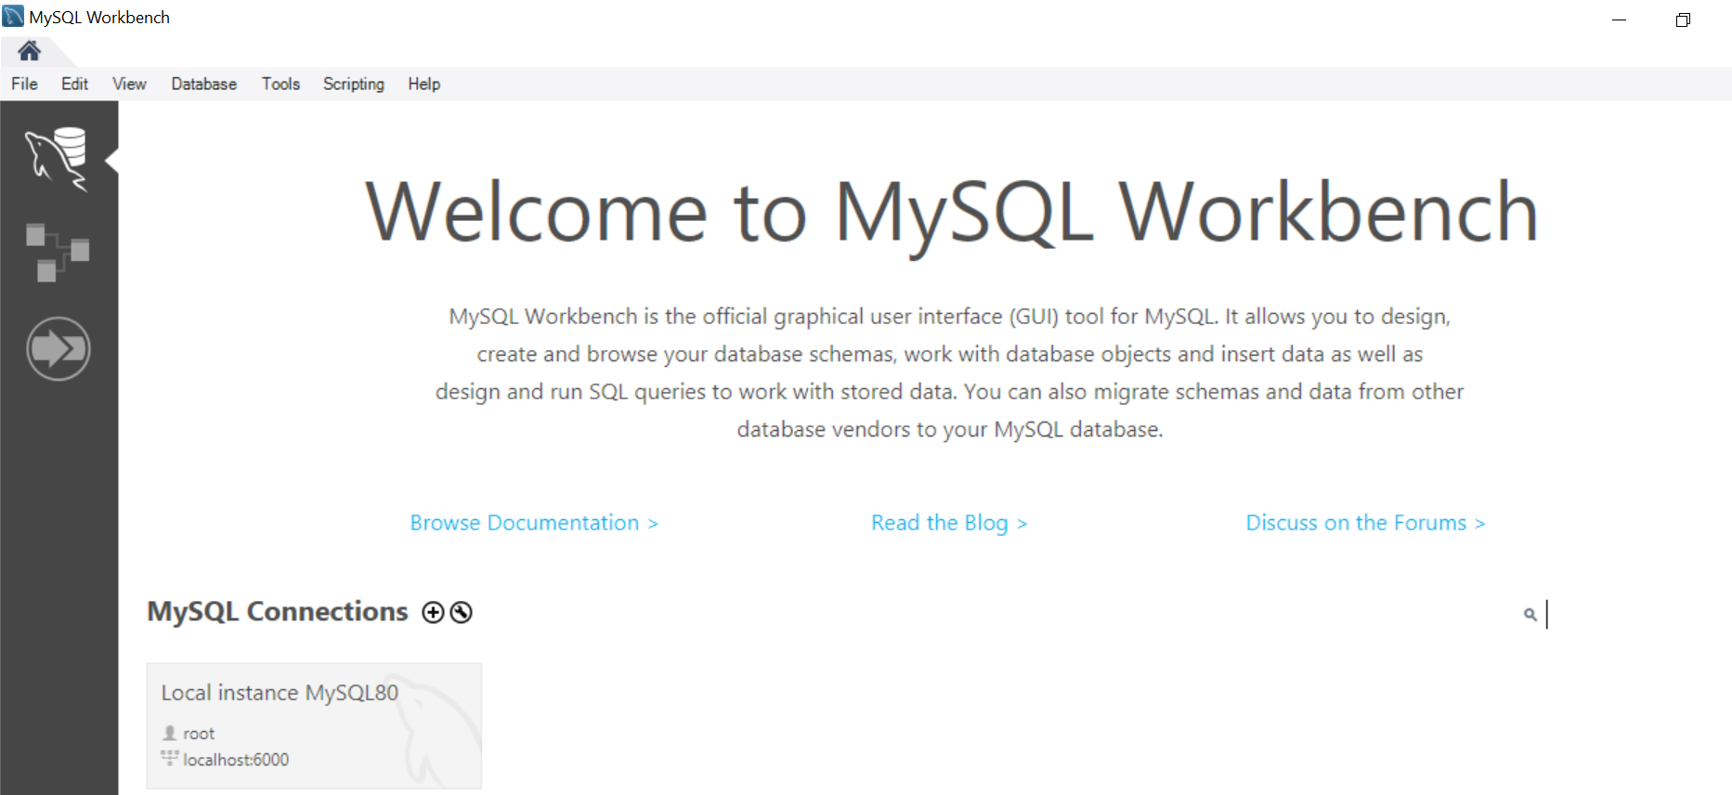
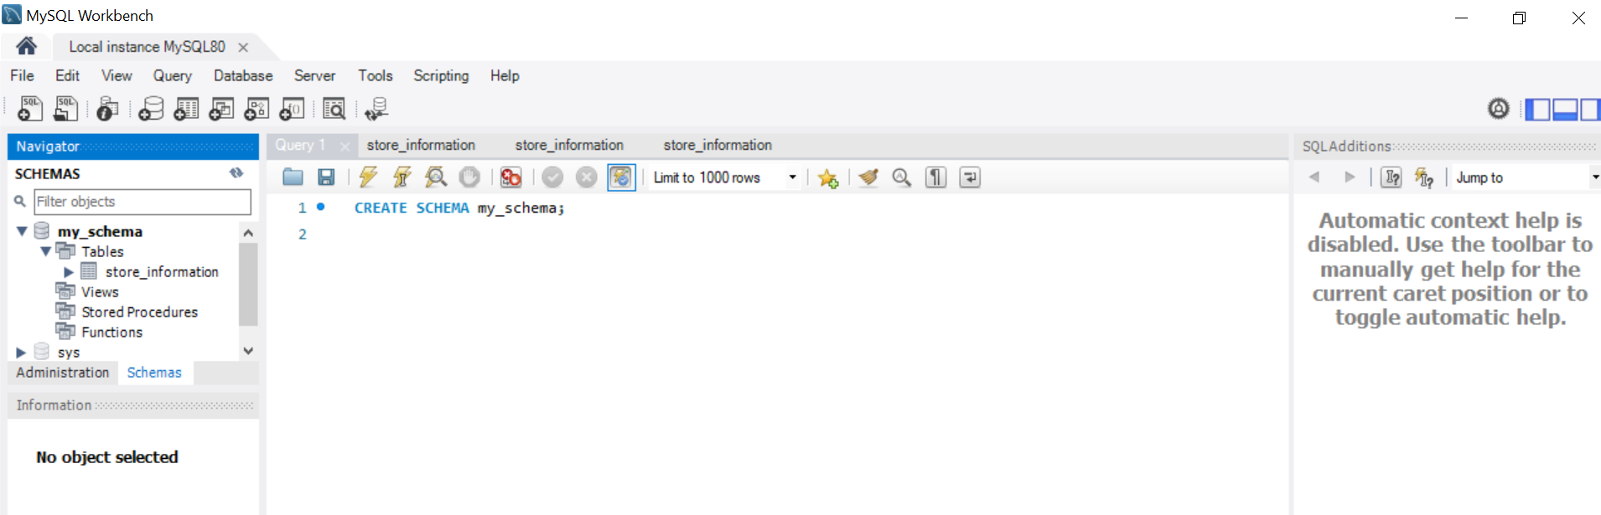

Github link : https://github.com/Zainabtahir00/sdc

